PREP  - Clean prep table with fresh bleach and ethanol/IPA  - Confirm item list with Manager (description, product ID’s, quantities), electronic or paper  - Pick items and enter Lot#/SN’s into the Shipping Preparation section of the Inventory tab of Site spreadsheet (can use paper worksheet first)  - Update any modified item info in these columns  - Create Packing List tab for this shipment  (Copy/pasting from Inventory tab)  - Print out Packing Lists (2 versions: Site & Internal)  - With Manager - confirm product ID’s and quantities by checking off Internal Packing List  Manager Initials _______________  - If any changes, updates are to be made on Inventory tab and then copied to Site Packing List  - Pack checked off items into box  - Put Site Packing List inside box  - Measure box dimensions and weight (record ->)  - When shipment is finalized, copy Ship Qty to Shipping History section of the Inventory tab  SHIP  - Create Ship Label in Carrier portal | 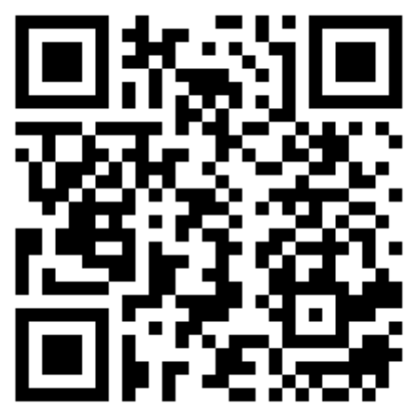 | SOP-030-B_1 Shipping - Log GForm
Date:

Location:
Shipper Name:
Manager Name:
Destination (Site):
Shipment Name:
Shipping Carrier:
Shipping Speed:
Box Dimensions (in):
Box Weight (lbs):
Insurance ($):
Cost ($):
Pickup or Dropoff (circle one)
If Dropoff, Location & Time:
- Print the Shipping Label
- Cover Ship Label entirely with tape or other clear plastic
- If insured, print 2 copies and leave on front desk for Carrier person to sign
  - Verify Carrier person takes copy and you keep signed copy
- Drop off or wait for pickup as needed (must request pickup by 2pm).

FOLLOWUP
  - Email “Ship To Contact” from your support@floodlamp.bio (see “Info” tab of Site spreadsheet), using Shipping Confirmation Message Template (Ambient)
- Notify FL support staff member for Shipping Confirmation followup:

Name__________________________________ Initials_____________
- Log this Run Form with Log GForm link

